MyDesign Portfolio
Element D Initial Template

How to use this template
Students: The template below is one way to present your design ideas, but the specific assignment given by your instructor may require a different structure or dictate different details. If you make a copy of this template to edit for your own design ideas, be sure to delete the instructions.

Guidance before filling out the template on the next page:
Because you will iterate on your design multiple times, you will need to create multiple copies of these sections. Think of Element D as a diary that you will date and keep adding to throughout your work until your final iteration. It’s critical that iteration shines through in this Element.
You should begin with many design ideas that reflect the individual ideas of your group members and then the group ideas. Number these ideas and include a date, description, drawing, and details for each.
After you have created an initial set of ideas, document your decision making on which design to include, ideally with a design matrix. Create a plan of work, ideally using a Gantt chart that may be housed in this document or in a different day-to-day document. Generate a design blueprint with enough details that someone else not familiar with your project could also build your design.
You will then proceed forward to build and test this design, returning to Element D afterwards when you are ready to create more design ideas. Fill out each of these steps again.

Element D: Design Concept Generation, Analysis, and Selection

Design Idea Generation (D1)
This section focuses on the process of generating solutions. The initial rounds should include every idea you come up with but the subsequent rounds of ideation should lead to viable options. Each idea should include not only words, but also a picture. Use as many copies of this sub-template as needed.
Design Idea #1
Date: 3/7/25
Description: Three legged stand holding up a guitar.
Drawing that includes distinguishing information such as scale, dimensions, and materials:
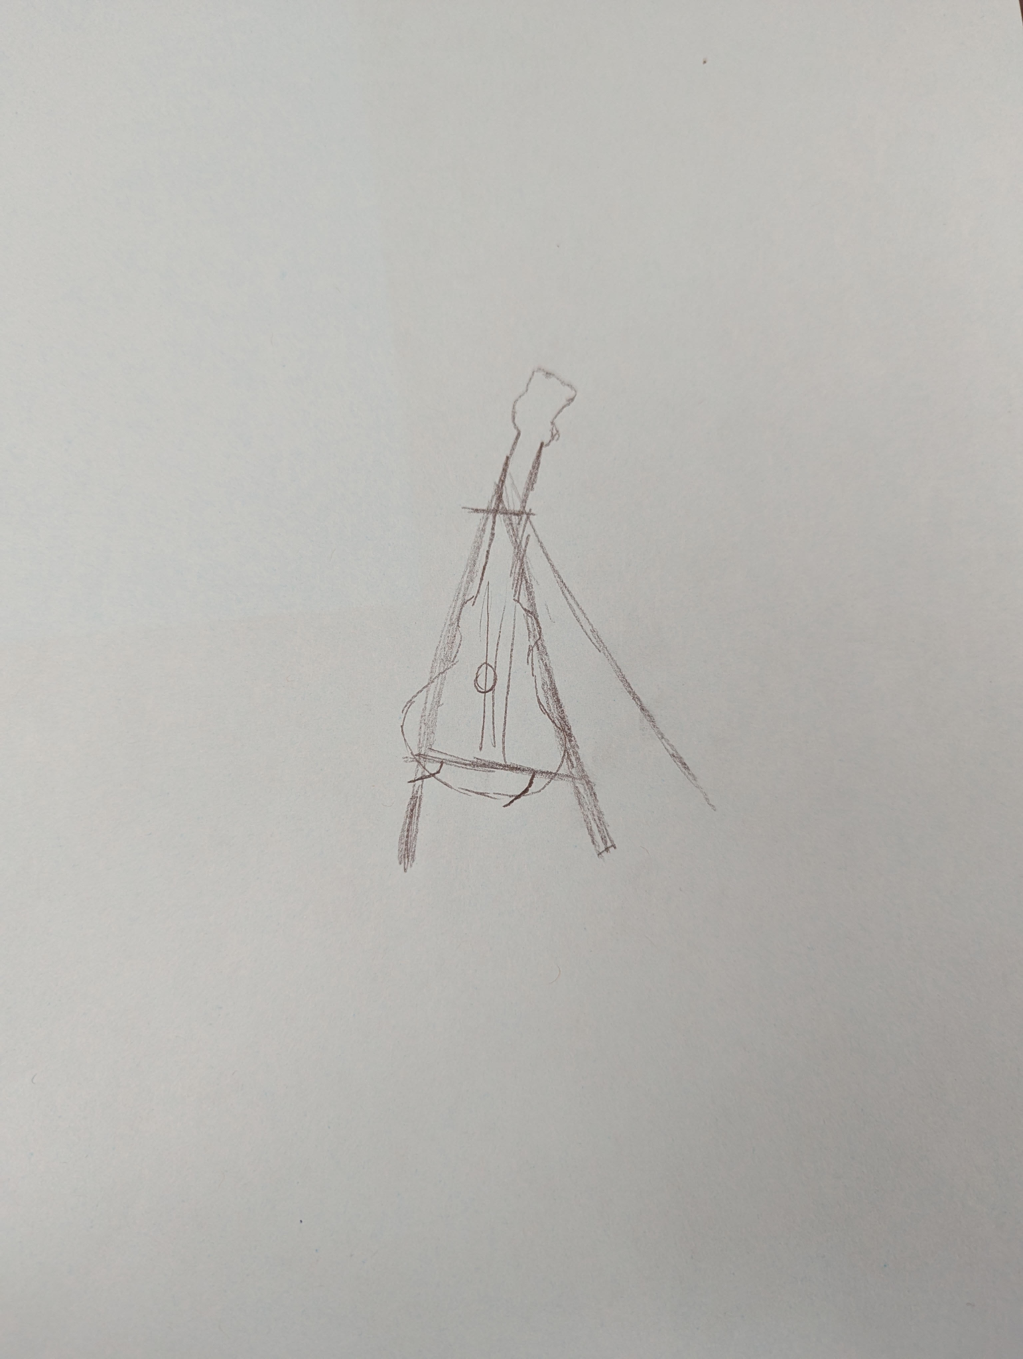

Design Idea #2
Date: 3/7/25
Description: Two parallel bars that can hold multiple guitars.
Drawing that includes distinguishing information such as scale, dimensions, and materials:
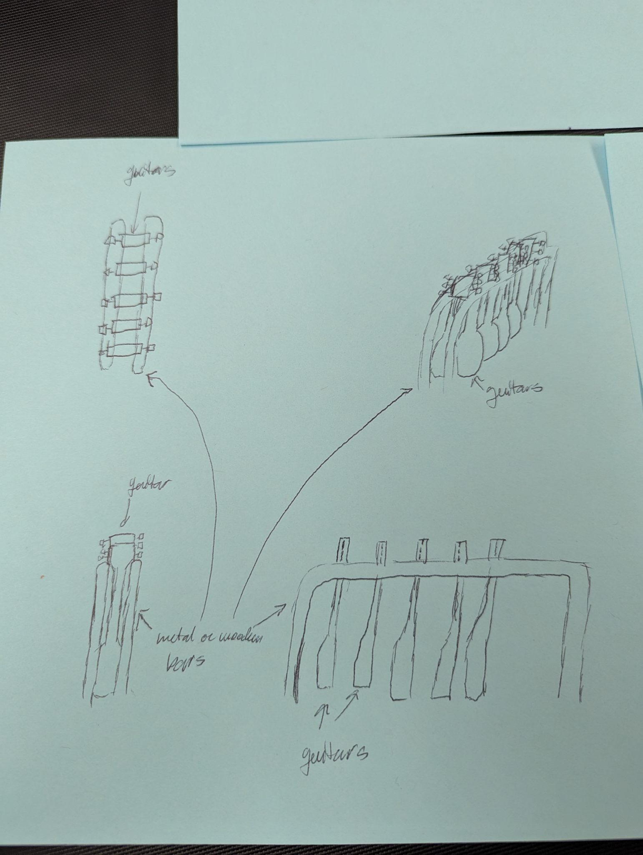
Design Idea #3
Date: 3/7/25
Description: Two legged stand with arms holding the guitar higher up.
Drawing that includes distinguishing information such as scale, dimensions, and materials:
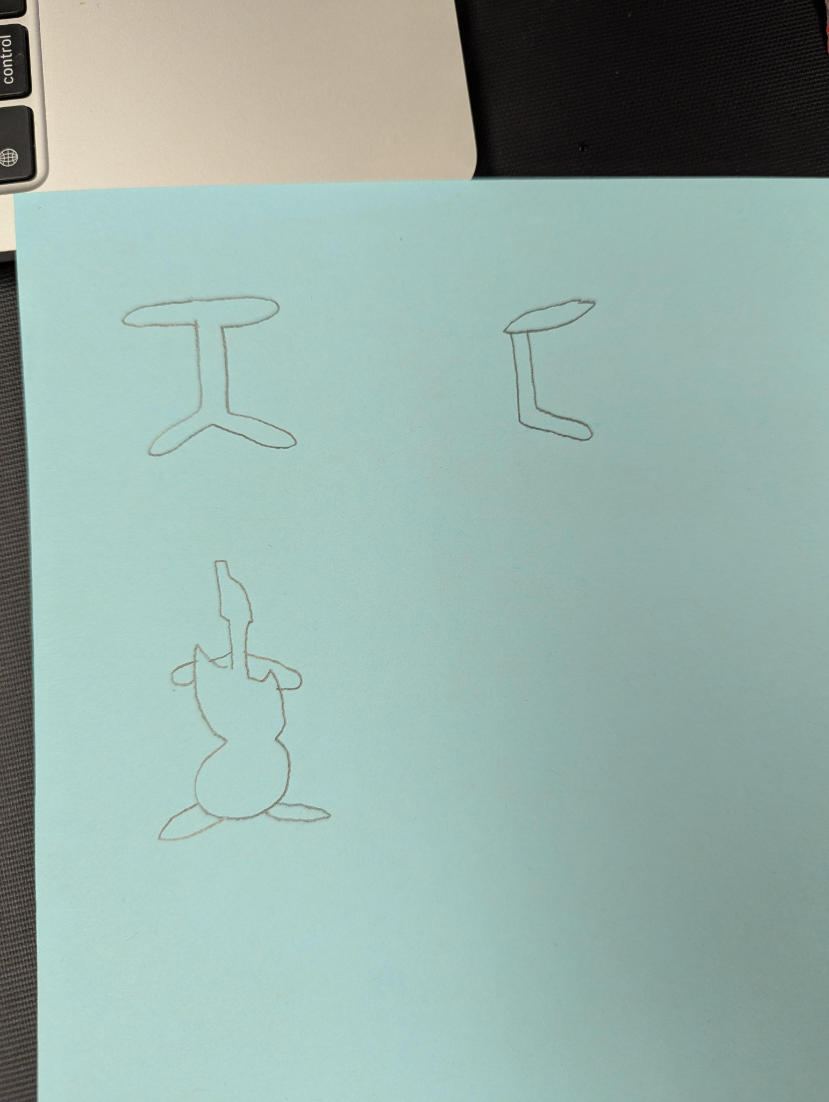

Design Idea Comparison and Selection (D1, D2)
When you’ve finished generating ideas, you must compare your design options according to all your design requirements. Incorporate the priority of those requirements when comparing design options. A decision matrix (perhaps a Pugh Matrix) is encouraged since it allows for systematic, weighted comparisons. If using weights in a decision matrix, be sure to explain and justify the weighting based on your design requirements. You may use the weighted design matrix template below, inserting your criteria and design options.

 | weight | Option 1 | Option 2 | Option 3
Time to build | 20% | 1 |  | 1
Accessibility | 30% | 1 |  | 1
Cost | 30% | 1 |  | 1
Multi-guitar | 10% |  | 1
Creativity | 10% |  | 1
score | 100% | 80% | 20% | 80%

Our team chooses design ______Option 3______ to solve the community problem.

Design Blueprint (D4)
Describe all of your design's details such that someone unfamiliar with your project can build your prototype. Include sketches, dimensions, CAD (if taught in your class), manufacturing methods, material choices, supply lists, and costs. Record the requirements this prototype idea has.
When you iterate on this idea, you will copy the design blueprint section for the second design.
Design Blueprint #1
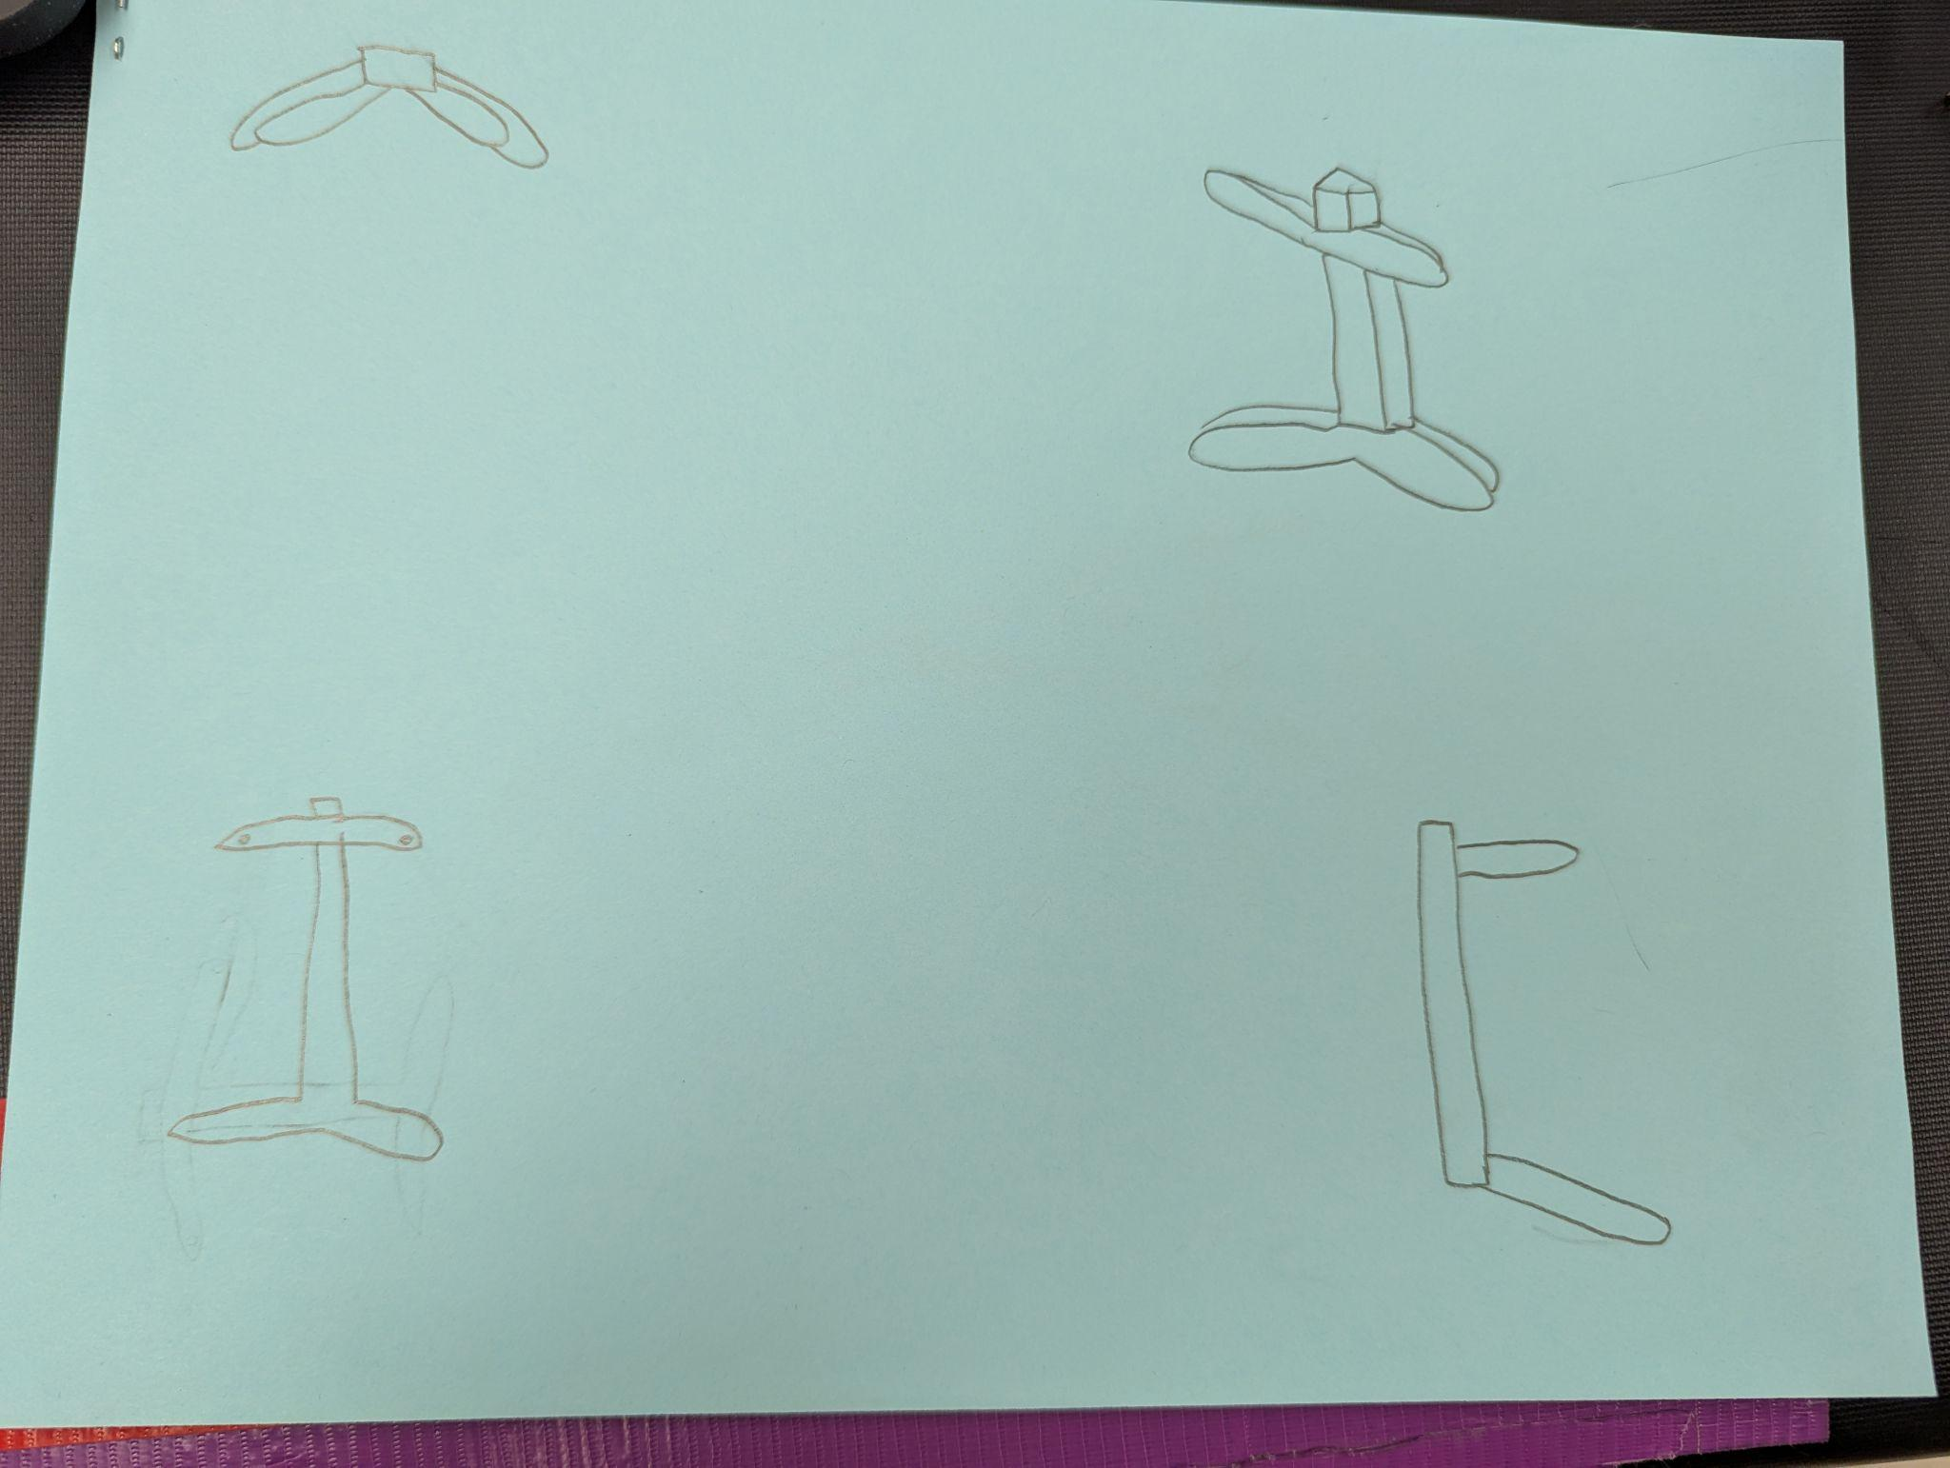
Date: 3/10/25
Sketch: Design #3
Manufacturing Methods: Handmade
Step 1: Create the spine
Step 2: Create the two lower legs
Step 3: Create the two upper arms
Supply List and Potential Costs: Wood, screws, wood glue
Item | Cost each | # needed | Total
Spine | $2 | 1 | $2
Arms | $2 | 2 | $4
Legs | $2 | 2 | $4
Total Cost |  |  | $10

Plan of Action (D3)
A Gantt chart is encouraged to lay out the primary steps expected on a visual timeline. Larger tasks from the Gantt chart should be broken down further into detailed sub-tasks, which may be housed in a different day-to-day document. Discrete tasks should include enough detail such that others could replicate the efforts, such as procedures, materials, tools, status, etc. You may use the Google Sheets document at this link to start your Plan of Action.

Iterations for the Solution:
How have you changed your prototype? Record each iteration here. You may copy this blueprint for additional iterations.
Design Blueprint #
Date:
Sketch:
Manufacturing Methods:
Step 1:
Step 2:
Step 3:
Supply List and Potential Costs:
Item | Cost each | # needed | Total
Total Cost

Rubric
Element D: Design Concept Generation, Analysis and Selection
 | 5 | 4 | 3 | 2 | 1 | 0
1. Process for Generating & Comparing Possible Solutions. The Process for Generating Possible Solutions _____________. | was comprehensive, iterative, and consistently defensible (viable design highly likely) | was thorough, iterative, and generally defensible (viable design likely) | was adequate, generally iterative and defensible (viable design is possible) | was partial or overly general and only somewhat iterative and/or defensible (raising issues with the design viability) | was incomplete or minimally iterative and/or defensible (raising issues with the design viability) | was not evident that there was an attempt
2.Design Solution Choice. The Design Solution chosen ____________. | was well-justified and demonstrated attention to all design requirements | was justified and demonstrated attention to most if not all design requirements | was explained with reference to at least some design requirements | was not sufficiently explained with reference to design requirements | lacked support related to design requirements | was not attempted or evidence not provided
3. Plan of Action. The plan of action _____________. | has considerable merit and would easily support repetition and testing for effectiveness by others | would support repetition and testing for effectiveness by others | might not clearly or fully support repetition and testing for effectiveness by others | has insufficient detail to allow for testing for replication of results | is lacking to the point that the design solution cannot be tested | cannot be executed or does not exist

5/5/25

Process for Generating Solutions: We used lots of different online images for inspiration and just general deliberation and brainstorming
Design Solution Choice: Our solution has two legs, a sturdy spine, and two arms. It is cheap, strong, and can be easily used.
Plan of Action: We will build two prototypes: a small one and a large one. We will test the small one first and, based on our observations, modify the large one based on those observations. The small one will be made out of cardboard and tape, cut and taped into the right shapes and assembled.

